**What is Analytics?**

* It is concerned with turning raw data into insight for making better decisions.
* Analytics is a field which combines data, information technology, statistical analysis, quantitative methods and computer based models into one.
* Analytics is the discovery, interpretation and communication of meaningful patterns in data.

**Needs for Analytics**

* Cost Reduction
* Better Marketing and product analysis.
* Organizational analysis
* Better and faster decision makings.

**Analysis vs Analytics**

* Analysis looks backwards over time providing marketers with a historical view of what was happened.
* Typically analytics look forward to model the future or predict a result.

**Domains of Analytics**

* Pricing Analytics
* Marketing Analytics
* Retail Sales Analytics
* Risk & Credit Analytics
* Collection Analytics
* Financial Service Analytics
* Fraud Analytics
* Healthcare Analytics

**Business Intelligence vs Business Analytics**

|  |  |
| --- | --- |
| **Business Intelligence** | **Business Analytics** |
| Required to run business | Statistical Analysis and predictive modeling to improve business planning |
| Process of collecting data from all sources and preparing it for BA | Analysis of the answers provided by Business intelligence |
| Answers what happened | Answers why it happened and whether it will happen again |
| Includes reporting, automated monitoring and alerting, dashboard, scorecards, | Includes statistical and quantitative analysis, data mining, predictive modeling |

**Levels of Analytics**

**Descriptive Analytics**

Gain insights from historical data with reporting, scorecard, clustering etc.

**Diagnostic Analytics**

Drill down to the cause, modeling the behavior using regression, logistic, classification, association rule mining.

**Predictive Analytics**

Employs predictive modeling using statistical and machine learning techniques to forecast.

**Prescriptive Analytics**

Recommends decisions using optimization and simulation etc.

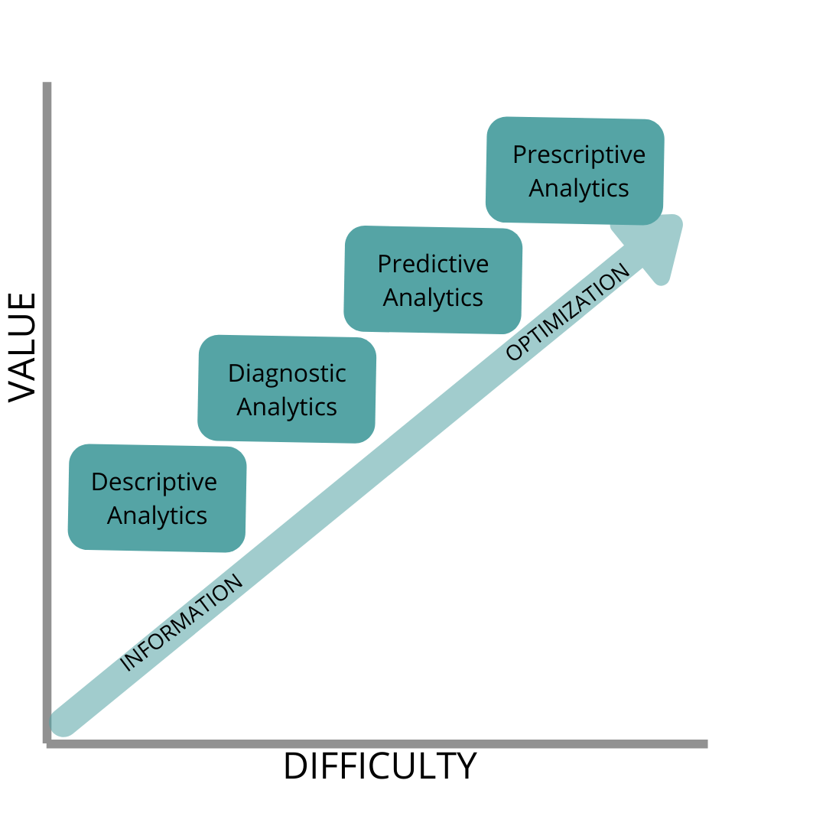

**CRISP-DM Framework: How to do Analytics**

CRISP-DM stands for Cross-Industry Process for Data Mining. This methodology provides a structured approached to planning a data mining project.

Steps Include:

* Business Knowledge
* Data Understanding
* Data Preparation
* Modeling
* Evaluation
* Deployment

